**Advanced Code Consultants, LLC East Union Township**

**Pennsylvania Uniform Construction Code**

**Commercial**

(Non- Residential – other than One- and Two- Family Dwellings)

**PERMIT FEES**

|  |  |
| --- | --- |
| **PA UCC Non- Residential Plan Review Fees** | |
| Up to $10,000,000 construction cost  from $10,000,001 to $100,000,000 construction cost from $100,000,001 and over construction cost  $150 minimum per discipline | 1%  .25%  .10% |
| **PA UCC Non- Residential Inspection Fees** |  |
| Up to $10,000,000 construction cost.  from $10,000.001 to 90,000,000 construction cost. From 90,000,0001 and over construction cost.  $200 minimum per discipline. | 1.5%  1.0%  0.5% |

|  |  |
| --- | --- |
| **Re-inspection/Additional Inspection Fees** | |
| Each Re-inspection | $125.00 minimum |

* 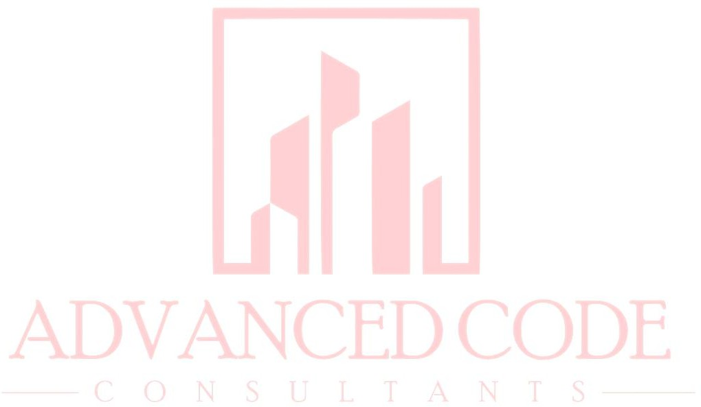Notes
* *Mechanical, Electrical, and Plumbing Permit Fees included*
* *Additional inspections charge re-inspection fees*
* *Permits issued after work has already begun will result in a 50% administrative fee.*
* Cost of construction to be determined by provided value or the ICC building valuation data- February 2024
* A $4.50 surcharge per permit is required to be assessed on each permit issued, in accordance with Pennsylvania Act 157 of 2006.